J58 (JT11D-20) Preliminary Design and Analysis

Christian J. Lagares,[1] Edwin R. Aponte[2] and Joel Quijano [3]

*Department of Mechanical Engineering, University of Puerto Rico at Mayaguez*

**As part of the INME 4707 course offered at the Department of Mechanical Engineering, University of Puerto Rico at Mayaguez, we are required to model and analyze the thermal performance of a J58 Turbojet engine.**

1. **Nomenclature**

*T0* = ambient temperature

*T1* = inlet temperature

*T2*= compressor inlet temperature

*TD* = fourth stage compressor temperature

*T3* = burner inlet temperature

T4 = turbine inlet temperature

T5 = turbine exit temperature

*T6* = afterburner flame-holder temperature

*T8* = nozzle temperature

NEGT = Nominal Exhaust Gas Temperature

*z* = altitude

*M* = Mach Number

= Thrust

*QLHV* = Fuel Lower Heating Value

1. **Introduction**

INSERT INITIAL INTRODUCTION

## Problem Statement

To gain a better understanding of turbojet engines it is important to analyze the engine characteristics over a range of condition to fully grasp the capabilities of the engine. To that end, an analytical model will be developed that describes the impact of changes in component characterization on the overall performance of a turbojet engine. This will be done for a range of conditions to survey the design space.

## Background Information

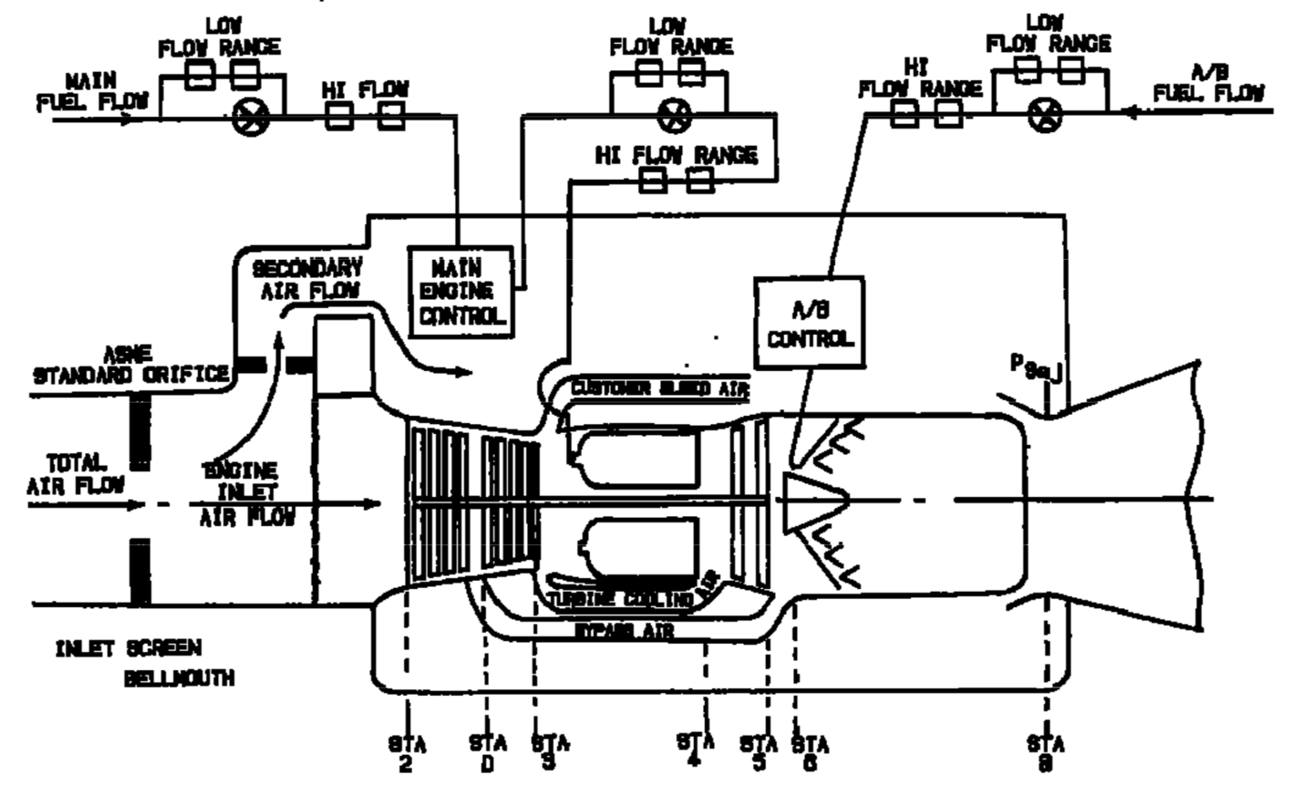

Figure 1: Standard J11D-20 Station Nomenclature [1]

Table 1: Maximum Operating Temperatures [1] [2]

|  |  |  |
| --- | --- | --- |
| COMPONENT/STAGE | TEMP (ºF) | TEMP (ºC) |
| Inlet T1 | 800+ | 426+ |
| COMPRESSOR Inlet T2 | 800+ | 426+ |
| COMPRESSOR 4th Stage TD | 1050 | 565.56 |
| COMBUSTOR Inlet T3 | 1300 | 704.44 |
| TURBINE Inlet T4 | 2000 | 1093.33 |
| TURBINE Exit T5 | 1450 | 787.78 |
| AB T6 | 3200 | 1760 |
| Exhaust NOZZLE T8 | 1500 | 815.15 |

The JT11D-20 variant of the P&W J58 engine has several components that merit some explanation. For instance, Figure 1 depicts a Bypass Air and Secondary Air Flow; the engine behaved as a traditional afterburning turbojet from subsonic to Mach 2.2, but transitioned to a turboramjet at Mach 2.2 . Above Mach 2.2, 6 valves bypass air from the fourth compressor stage (Station D) to the afterburner thereby combining a turbojet with a compressor assisted ramjet. However, this report will limit the analysis to conditions below Mach 2.2 in order to consider the turbojet nature of the JT11D-20. The secondary airflow depicted in Figure 1 allows “descent at low airflow, low power, without unstarting the inlet.“ [3] (It is also shared with the cowl shock trap bleed as per [3].)

The JT11D-20 was designed for a wide range of operational requirements which included sub- and supersonic flight conditions and a wide range of altitudes. This versatility requires the designed to be evaluated at several conditions which are listed in Table 3. The engine must be capable of performing Buddy Missions, Recon Missions, Long Range Flight Deployments plus the typical Takeoff/Landing conditions. Additionally, the aircraft usually performed high altitude, high Mach flights, but these will not be evaluated due to the Turbo-Ramjet limitation after Mach 2.2. The majority of the flight conditions closely resemble an actual flight condition possibly experienced by an SR-71.

Table 2: Engine Specs

|  |  |  |
| --- | --- | --- |
| SPECIFICATION | VALUE RANGE [EN] | VALUE RANGE [SI] |
| **Altitude** [4] | **25K-90K ft** | **7.62 – 27.43 km** |
| **Speed** [5] | **Mach 0.75 – 3.2** | |
| **Dry TSFC @ Max Thrust** [6] | **0.8 lb/lbf hr** | **81.6 kg/kN hr** |
| **Wet TSFC @ Max Thrust** [6] | **1.9 lb/lbf hr** | **164 kg/kN hr** |
| **Fuel** [7] | **JP-7** | |
| **Fuel Storage** [8] | **80,285 lb** | **36,416 kg** |
| **Fuel Lower Heating Value** [9] | **5.48 kWh/lb** | **43,682 kJ/kg** |
| **Thrust** [7] | **32,500 lbf** | **144,567 N** |
| **Air Volume Flow @ Cruise** [10] | **100K ft3/s** | **2831.68 m3/s** |
| **Compression Ratio < Mach 2.2** [8] | **8.8:1** | |
| **Compressor** [11] | **8-Stage Axial** | |
| **Turbine** [11] | **2-Stage** | |
| **Weight** [11] | **6,500 lb** | **2,948 kg** |
| **Air Mass Flow** [8] | **326-450 lb/s** | **147 – 204 kg/s** |
| **Dry Fuel Mass Flow @ Max** | **5.55 lb/s** | **2.52 kg/s** |
| **Wet Fuel Mass Flow @ Max** | **17.94 lb/s** | **8.14 kg/s** |
| **Dry Fuel to Air Ratio** | **0.012-0.017** | |
| **Wet Fuel to Air Ratio** | **0.0398-0.055** | |

# Methodology: Model Description

Modelling a JT11D-20 requires a non-linear approach; in other terms, the engine requires the coupled equations be solved simultaneously front-to-back and back-to-front in order to better approximate the engine’s actual functioning. For instance, the nominal EGT (T8) is provided by [2] as a function of compressor inlet temperature; therefore, this parameter is fixed once T2 is determined. The inlet design is also a major factor affecting the overall model. Given the supersonic nature of the SR-71 plane, the inlet was designed to minimize the losses incurred by shock waves. The recovery factor is then nonlinear and less than one for a typical flight.

### Ambient

Atmospheric condition will be modelled using [15] based on [16] and [17] with an offset temperature approximating typical aircraft temperatures.

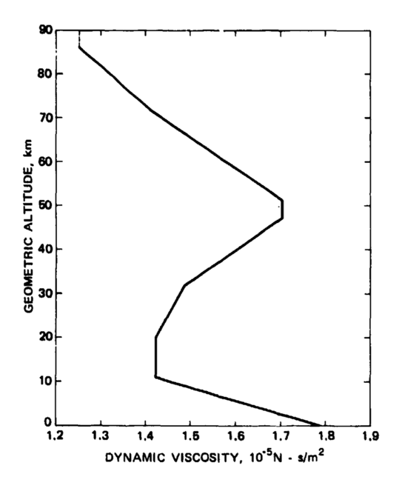

Figure : Standard Atmosphere Dynamic Viscosity [17]

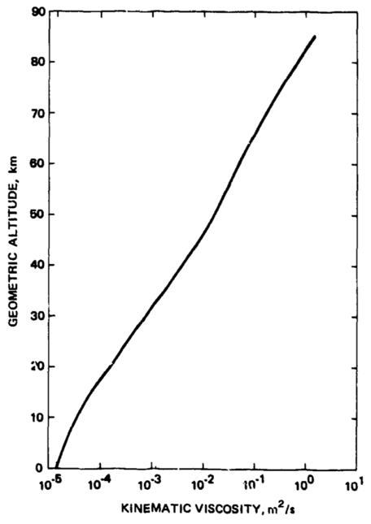

Figure : Standard Atmosphere Kinematic Viscosity [17]

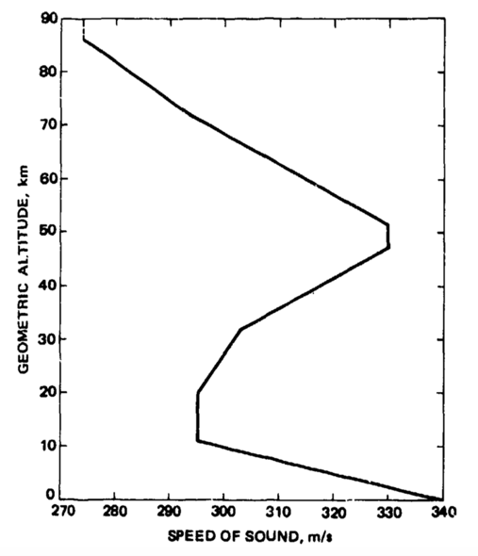

Figure : Standard Atmosphere Speed of Sound [17]

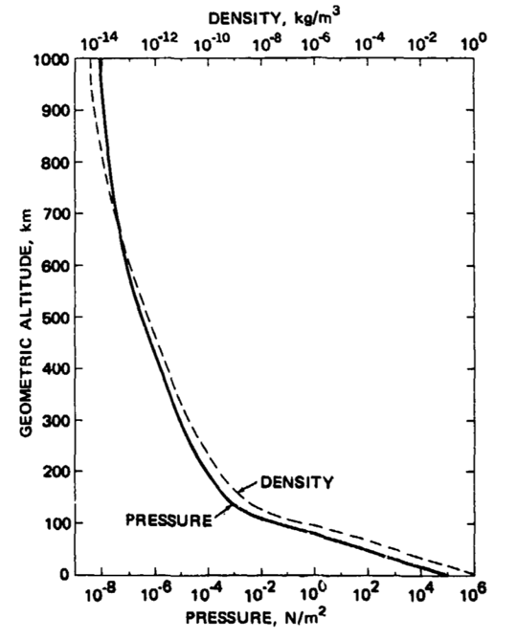

Figure : Standard Atmosphere Pressure [17]

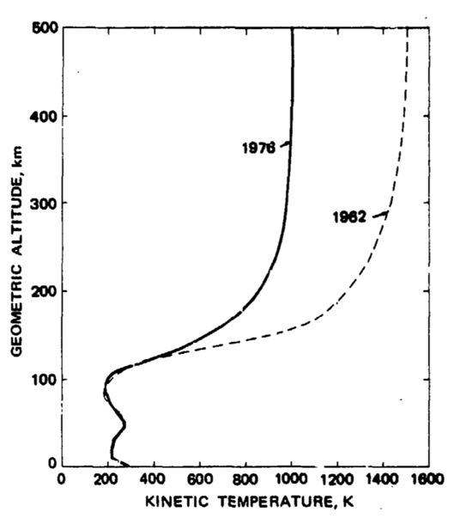

Figure : Standard Atmosphere Kinetic Temperature [17]

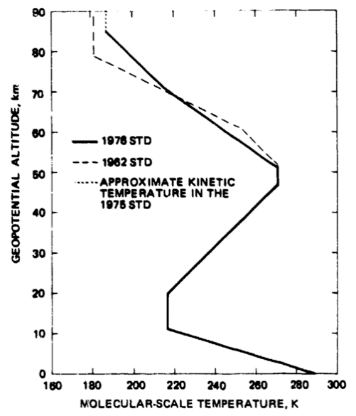

Figure : Standard Atmosphere Molecular-Scale Temperature [17]

### Inlet

The inlet’s recovery factor will be modelled after the more conservative curve in Figure 2.

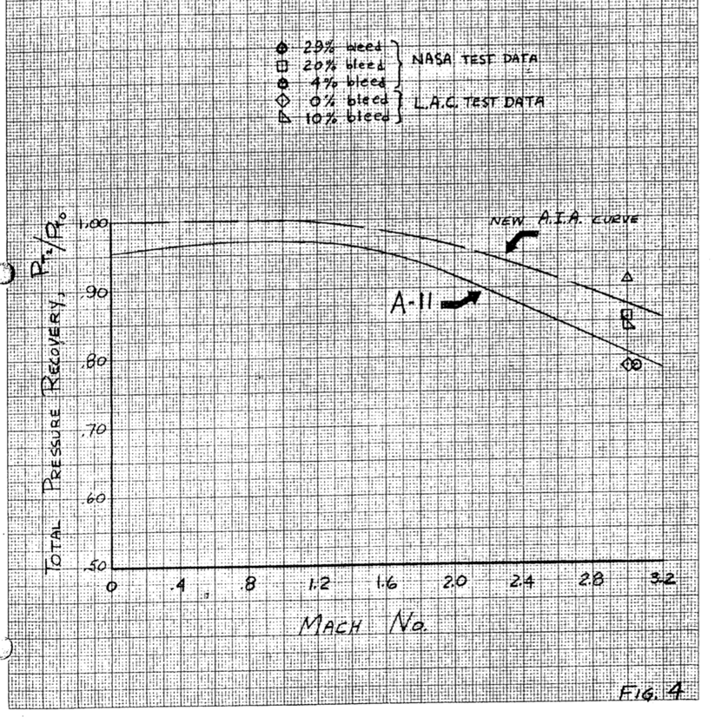

Figure : Expected Inlet Performance [18]

The air density will be modelled using Equation (1). The speed of sound inside the inlet is then determined as shown in Equation (2). From this change in density and the total pressure recovery, the inlet temperature (T1 or T2 for typical operations) can be determined as seen in Equation (3).

()

()

()

### Nominal EGT

The EGT is given by Figure 3 extracted from [2].

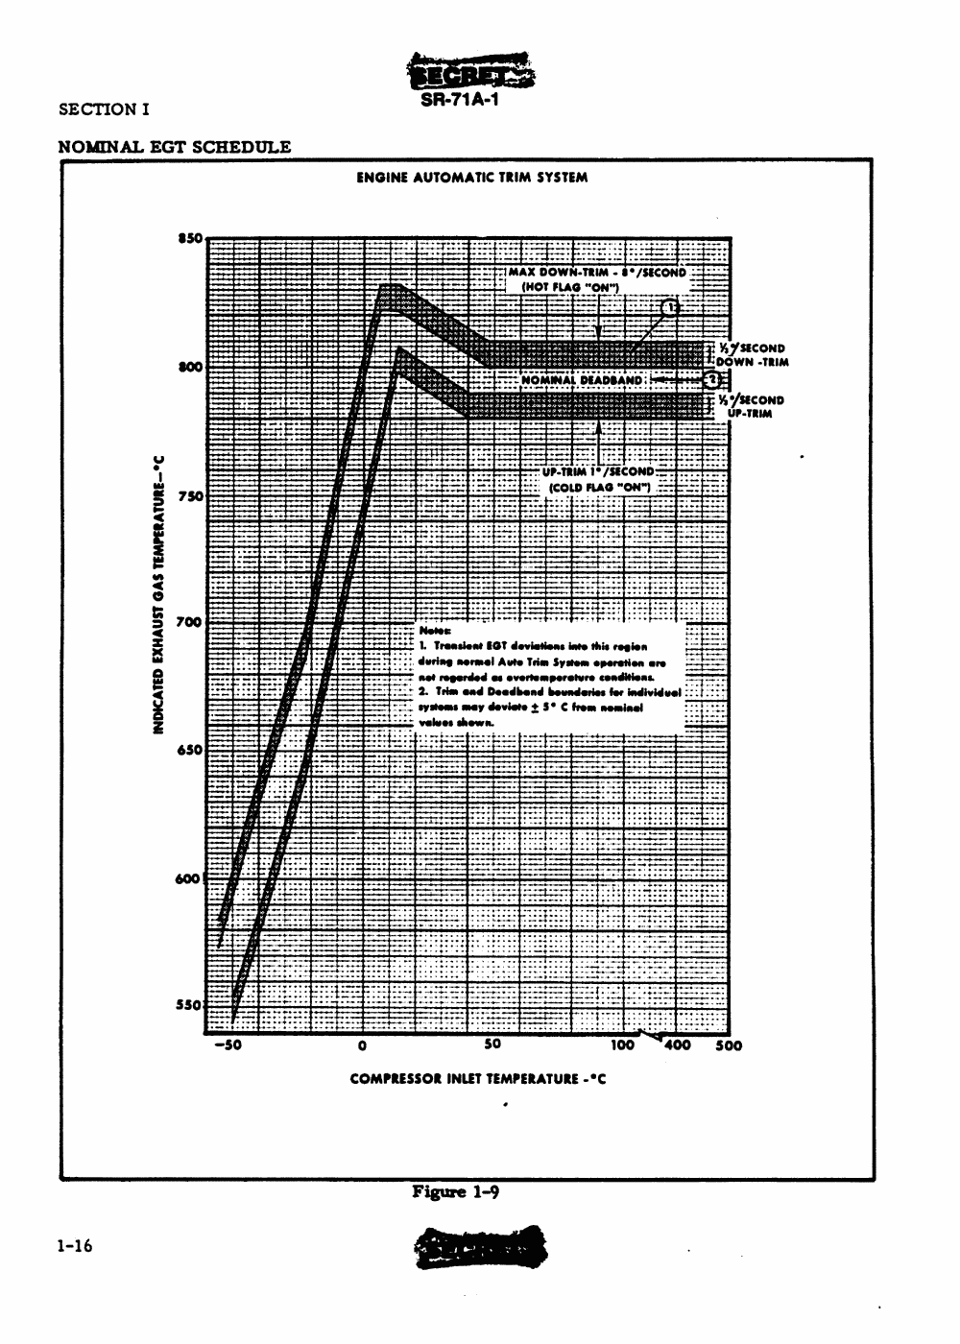

Figure : Indicated EGT vs Compressor Inlet Temperature [2]

### Compressor

As per [11], the compression ratio is typically 8.8 and will be assumed constant throughout the model.

### Burner

The JT11D-20’s burner is another source of complexity in the overall design. Albeit the main fuel consumed is JP-7, it is typically mixed with a nitrogen-based additive to promote the ignition of the stable JP-7 [8] [2]. The model assumes JP-7 to be the only fuel present; thereby treating the additive as a neglectable component per unit volume of fuel. Another major assumption presumes the turbine inlet temperature (T4) to remain constant at a maximum value.

The afterburner will be modeled as the burner, however the JP-7 additive assumption is relaxed as the fuel added to the AB is exclusively JP-7.

### Nozzle

The Nozzle’s Area is variable and is a major limiting factor in the numerical modelling still being researched.

### Model Validation

The model will be validated at standby with maximum afterburner where a 34000 lbf is expected at 1.9 pounds of JP-7 per hour per pound of thrust generated.

### JT11D-20 Conditions

Table : Flight Conditions

|  |  |  |  |
| --- | --- | --- | --- |
| Condition ID | Altitude [ft] | Mach | Afterburner |
| Takeoff [2] | 0 (@ Sea level) | 0.3542 | ON |
| Refueling/Buddy Mission [2] | 25000 | 0.75 | OFF |
| Climbing [2] | 30000 | 1.25 | ON |
| Concorde [12] | 60000 | 2.00 | ON |
| YF12A (03/18/65) [13] | 65000 | 2.2 | ON |
| A12 Max Altitude at Mach 2.2 [14] | 75000 | 2.2 | ON |
| Lake County Airport [14] | 9928 | 0.3545 | ON |
| Lowest Altitude at Mach 1.0 [14] | 15000 | 1.0 | ON |
| Maximum payload Research Mission [5] | 70000 | 3.0 | ON |
| Cruising airplane capacity [5] | 85000 | 3.2 | ON |
| Acceleration and Climbing[5] | 70000 | 3 | ON |
| Cruising [] |  | 3.25 |  |

### Implementation

The model’s implementation language is Matlab and the code is being maintained in GitHub for source control facilitation.

# Appendix

## Model

The Codebase has been organized as follows:

* EngineModel
  + afterburner.m
  + burner.m
  + compressor.m
  + inlet.m
  + nozzle.m
  + shock_trap.m
  + turbine.m
* PerfParameters
  + flight_conditions.m
  + impulse.m
  + overall_efficiency.m
  + propulsive_efficiency.m
  + range.m
  + thermal_efficiency.m
  + thrust.m
  + tsfc.m
* utils
  + atmos
    - atmos.m
    - densityalt.m
    - tropos.m
    - license.txt
  + EngineParameters
    - atm2comp.m
    - engine.m
    - recovery.m
  + FlightManualUtilities
    - knots.m
    - nominalEGT.m
* Main.m

## Group Meetings

## Biosketch

Christian Lagares is currently an undergraduate student at the Department of Mechanical Engineering at the University of Puerto Rico at Mayaguez and an Artificial Intelligence/Machine Learning Researcher at SIL Technologies, LLC. His main research interests include Supervised Learning Strategies for Advanced Signal Analysis, Real Time Systems for Simultaneous DAQ/Processing in low power portable devices and AI-Enabled Materials.

# References

|  |  |
| --- | --- |
| [1] | P. Law, *SR-71 Propulsion System P&W J58 Engine (JT11D-20),* 2013. |
| [2] | *SR-71 Flight Manual,* Norton, CA: Norton, AFB, 1986. |
| [3] | J. T. Anderson, "How Supersonic Inlets Work: Details of the Geometry and Operation of the SR-71 Mixed Compression Inlet," Lockheed Martin Corporation, 2013. |
| [4] | C. L. Johnson, "Development of the Lockheed SR-71 Blackbird," *Lockheed Horizons,* 1982. |
| [5] | T. R. Conners, "Predicted Performance of a Thrust- Enhanced SR-71 Aircraft with an External Payload," *NASA Technical Memorandum 104330,* 1997. |
| [6] | Jet Engine Specification Database, "Military Turbojet/Turbofan Specifications," [Online]. Available: http://www.jet-engine.net/miltfspec.html. [Accessed 11 04 2018]. |
| [7] | Atomic Toaster, "A Look at the Pratt & Whitney J-58JT11D-20," 22 August 2012. [Online]. Available: http://atomictoasters.com/2012/08/a-look-at-the-pratt-whitney-j-58jt11d-20/. [Accessed 17 03 2018]. |
| [8] | R. H. Graham, SR-71 Revealed: The Untold Story, Osceola, WI: Zenith Imprint, 1996. |
| [9] | Coordinating Research Council, Inc., "Handbook of Aviation Fuel Properties (CRC Report No. 530)," Society of Automotive Engineers, Inc., Warrendale, PA, 1983. |
| [10] | P. W. Merlin, "Design and Development of the Blackbird: Challenges and Lessons Learned," in *47th AIAA Aerospace Sciences Meeting Including The New Horizons Forum and Aerospace Exposition*, Orlando, FL, 2009. |
| [11] | National Air and Space Museum, "Pratt & Whitney J58 (JT11D-20) Turbojet Engine," [Online]. Available: https://airandspace.si.edu/collection-objects/pratt-whitney-j58-jt11d-20-turbojet-engine. [Accessed 17 03 2018]. |
| [12] | U. K. Saha, *Jet Propulsion: The Concorde Aircraft,* Guwahiti, India: Indian Institute of Technology Guwahiti. |
| [13] | L. Haynes, "Lockheed YF12A," [Online]. Available: http://www.sr71.us/yf12~1.htm. [Accessed 14 04 2018]. |
| [14] | "A12 Flight Manual with Technical Data Change," 1968. |
| [15] | S. Sartotius, "Standard Atmosphere," 3 07 2017. [Online]. Available: https://github.com/sky-s/standard-atmosphere. [Accessed 06 04 2018]. |
| [16] | Public Domain Aeronautical Software, "Properties Of The U.S. Standard Atmosphere 1976," 09 07 2017. [Online]. Available: http://www.pdas.com/atmos.html. |
| [17] | NOAA; NASA; USAF, "U.S. Standard Atmosphere, 1976," NOAA, Washington, D.C., 1976. |
| [18] | R. F. Boehme and et.al., "Proposal - A-11 - Appendix," Lockheed Aircraft Corporation California Division, 1959. |
| [19] | T. R. Conners, "Predicted Performance of a Thrust-Enhanced SR-71 Aircraft With an External Payload," , 1995. [Online]. Available: https://ntrs.nasa.gov/search.jsp?r=19970019923. [Accessed 24 3 2018]. |

1. Undergraduate Researcher, Bubble Dynamics Laboratory & SIL Technologies.
2. Undergraduate Student, Department of Mechanical Engineering, University of Puerto Rico at Mayaguez.
3. Undergraduate Student, Department of Mechanical Engineering, University of Puerto Rico at Mayaguez.